**TASK 13**

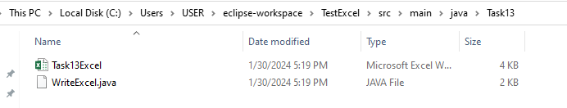

Excel file has been created using java program .

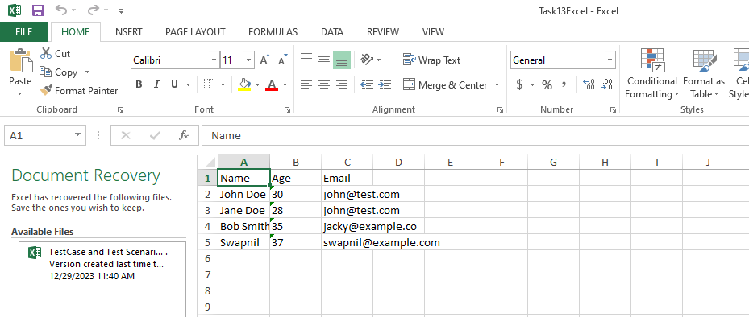

Data given is entered in excel using java program.